Lab#11
Design Header & Navigation bar with dropdown using Tailwind CSS.

Tag and Attribute Table:

HTML Tag / Class | Attributes / Usage | Description
<!DOCTYPE html> | HTML5 | Declares the document as HTML5.
<title> | Header and Navbar | Sets the browser tab title.
<script> | src | Loads the Tailwind CSS framework.
<body> | bg-gray-100 | Sets a light gray background.
<header> | bg-emerald-800 text-white p-4 | Creates a dark green header with white text and padding.
<div> | flex justify-between items-center | Arranges the logo and navigation horizontally with space between them.
<h1> | text-2xl font-bold | Displays the MyStore logo text in large, bold letters.
<nav> | flex gap-6 | Arranges navigation links in a row with spacing.
<a> | href="#" | Creates a hyperlink.
hover:text-lime-300 | Tailwind CSS class | Changes the text color to light green when hovered over.
<div> | relative group | Provides the positioning and hover group for the dropdown.
<button> | hover:text-lime-300 | Creates the Products dropdown trigger.
hidden group-hover:block | Tailwind CSS classes | Hides the dropdown initially and displays it when the parent group is hovered over.
absolute | Tailwind CSS class | Positions the dropdown relative to its positioned parent.
bg-white text-gray-800 | Tailwind CSS classes | Gives the dropdown a white background and dark text.
w-32 | Tailwind CSS class | Sets the dropdown width.
rounded-lg shadow-lg | Tailwind CSS classes | Adds rounded corners and a large shadow.
block p-2 | Tailwind CSS classes | Displays each dropdown link as a block with padding.
hover:bg-emerald-100 | Tailwind CSS class | Changes the dropdown item's background to light green on hover.
z-10 | Tailwind CSS class | Helps the dropdown appear above nearby content.
<!-- ... --> | HTML comments | Adds notes in the source code without displaying them on the webpage.

Final Outcome:
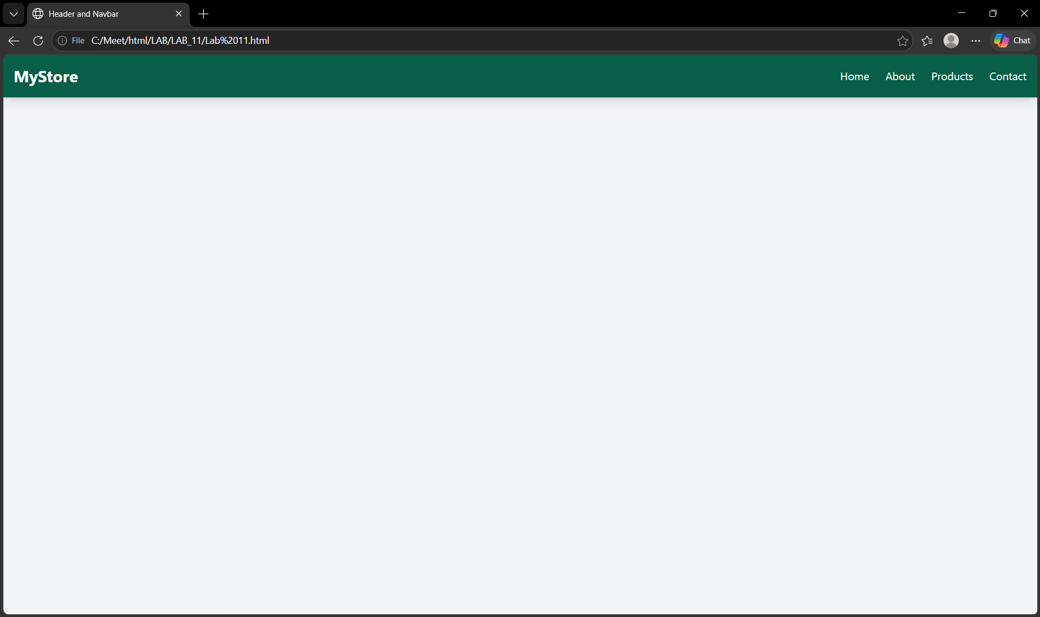

Code Snippet:

<!DOCTYPE html>
<html>
<head>
<title>Header and Navbar</title>
<script src="https://cdn.tailwindcss.com"></script>
</head>

<body class="bg-gray-100">

<!-- Header -->
<header class="bg-emerald-800 text-white p-4 shadow-lg">

<div class="flex justify-between items-center">

<!-- Logo -->
<h1 class="text-2xl font-bold">MyStore</h1>

<!-- Navigation -->
<nav class="flex gap-6">

<a href="#" class="hover:text-lime-300">Home</a>

<a href="#" class="hover:text-lime-300">About</a>

<!-- Dropdown -->
<div class="relative group">

<button class="hover:text-lime-300">
Products
</button>

<div class="hidden group-hover:block absolute bg-white text-gray-800 p-2 w-32 rounded-lg shadow-lg z-10">

<a href="#" class="block p-2 hover:bg-emerald-100">
Laptop
</a>

<a href="#" class="block p-2 hover:bg-emerald-100">
Mobile
</a>

<a href="#" class="block p-2 hover:bg-emerald-100">
Shoes
</a>

</div>
</div>

<a href="#" class="hover:text-lime-300">Contact</a>

</nav>

</div>

</header>

</body>
</html>

